

**APEXPEAK PTE LTD**

**Functional Specification Documentation**

SAP Journal Entry Import using Pastel Data

|  |  |
| --- | --- |
| **Version No.:** | **1.0** |
| **Date:** | **16-Jul-2014** |

Table of Contents

1. Objective 2

1.1 Objective 2

1.2 Background 2

2. G/L Account Mapping 3

2.1 User Defined Table for G/L Account Mapping 3

3. User Interface (UI) and Data Mapping 4

3.1 Sample User Interface (UI) 4

3.2 Data Mapping 4

3.3 Import Process 5

4. Validation 6

5. Appendix 7

# 1. Objective

## 1.1 Objective

The purpose of this functional specification is to design a UI or function that will allow user to import Pastel data in SAP Business One.

## 1.2 Background

ApexPeak Pte Ltd is a Singapore-based company. However, they have another entity in South Africa called Bibby Financial Services (Pty) Ltd. Every month end, user from South Africa will send a CSV file to Singapore for them to import Bibby’s data into SAP Business One under the Bibby company.

SAP Business One

ApexPeak Pte Ltd

APEX_LIVE

Pastel

Bibby Financial Services (Pty) Ltd

(CSV File)

SAP Business One

Bibby Financial Services (Pty) Ltd

BIBBY_LIVE

# 2. G/L Account Mapping

## 2.1 User Defined Table for G/L Account Mapping

Bibby’s Pastel system in South Africa has a different Chart of Accounts with Singapore’s SAP Business One. In order to import the data, G/L Account mapping between the two systems is needed. A User Defined Table (UDT) has been created in SAP Business One under the company Bibby (BIBBY_LIVE database) to serve this purpose.

This table contains the G/L Account Mapping between Bibby’s Pastel system and SAP Business One.

UDT Name: dbo.[@BIBBY_ACCT_MAPPING]

|  |  |  |
| --- | --- | --- |
| UI Column Name | Bibby Acct | Apex Peak SG Acct |
| Column Description | Pastel System G/L Account | SAP G/L Account |
|  | Sample Data | |
| DB Column Name | Code | Name |
|  | G/L Account 1 | SAP G/L Account 1 |
|  | G/L Account 1 | SAP G/L Account 2 |
|  | Debtor | SAP G/L Debtor Account |
|  | Creditor | SAP G/L Creditor Account |

User needs to provide the G/L account mapping during design stage. After go-live, user will have to maintain this table.

Tools 🡪 User-Defined Windows 🡪 BIBBY_ACCT_MAPPING – Bibby Account Mapping

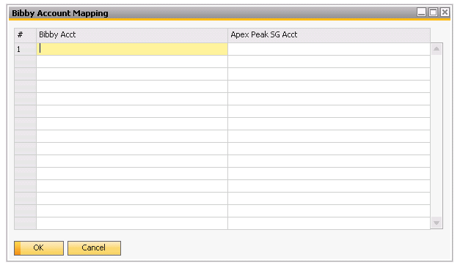

# 3. User Interface (UI) and Data Mapping

## 3.1 Sample User Interface (UI)

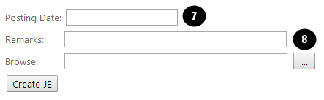

## 3.2 Data Mapping

The mapping of data is listed below.

Sample CSV:

|  |  |  |  |  |  |  |  |
| --- | --- | --- | --- | --- | --- | --- | --- |
|  |  |  |  |  |  |  |  |
|  | A | B | C | D | E | F | G |
| Row# | GDC | AccNumber | PPeriod | DDate | Refrence | Amount | RefNo |
| 1 | G | 3200000 | 102 | 01/04/2014 | ABSA011 | 39.00 | 1 |
| 2 | G | 3200000 | 102 | 01/04/2014 | ABSA012 | 14.00 | 1 |

Data Mapping:

|  |  |  |  |
| --- | --- | --- | --- |
|  | CSV File | SAP Journal Entry Header | SAP Journal Entry Line |
|  | GDC | - | - |
|  | AccNumber | - | JDT1.ShortName |
|  | PPeriod | OJDT.Ref1 | - |
|  | DDate | - | JDT1.TaxDate |
|  | Reference | - | JDT1.Ref1 |
|  | Amount | - | JDT1.Debit or JDT1.Credit |
|  | RefNo | OJDT.Ref2 | - |
|  | UI | SAP Journal Entry Header | SAP Journal Entry Line |
|  | Posting Date | OJDT.RefDate  OJDT.DueDate  OJDT.TaxDate | JDT1.RefDate  JDT1.DueDate |
|  | Remarks | OJDT.Memo | - |

## 3.3 Import Process

1. If GDC is G 🡪 map the AccNumber with the corresponding SAP G/L Account Number defined in the mapping table, i.e. each “G” AccNumber should have an entry in the mapping table.

If GDC is D 🡪 use the SAP G/L Debtor Account Number assigned to Debtor in the mapping table, i.e. all “D” AccNumbers will go into one SAP Debtor G/L Account.

If GDC is C 🡪 use the SAP G/L Creditor Account Number assigned to Creditor in the mapping table, i.e. all “C” AccNumbers will go into one SAP Creditor G/L Account.

2. If amount > 0, enter the amount to Debit side. If amount < 0, enter the amount to Credit side without the negative sign, i.e. absolute value. All amounts should follow local currency (South Africa Rand).

3. Each row in the CSV file corresponds to one journal entry line/detail.

4. The RefNo column in the CSV file denotes the grouping of entries, i.e. all rows having the same RefNo will go into one Journal Entry but each data row will go into one journal entry line/detail.

Example:

|  |  |  |  |  |  |  |  |
| --- | --- | --- | --- | --- | --- | --- | --- |
|  | A | B | C | D | E | F | G |
| Row# | GDC | AccNumber | PPeriod | DDate | Refrence | Amount | RefNo |
| 1 | G | 3200000 | 102 | 01/04/2014 | ABSA011 | 39.00 | 1 |
| 2 | G | 3200000 | 102 | 01/04/2014 | ABSA012 | 14.00 | 1 |
| 3 | G | 3900200 | 102 | 01/04/2014 | ABSA013 | 6299.59 | 1 |
| 4 | G | 3200000 | 102 | 01/04/2014 | ABSA014 | 586.90 | 1 |
| 5 | G | 8420000 | 102 | 01/04/2014 | ZContras | -6939.49 | 1 |
| 6 | D | APP001 | 102 | 02/04/2014 | 83 | 36958.80 | 2 |
| 7 | G | 1100100 | 102 | 02/04/2014 | 83 | -36958.80 | 2 |
| 8 | C | APP999 | 102 | 02/04/2014 | 83 | -35572.84 | 2 |
| 9 | G | 2000100 | 102 | 02/04/2014 | 83 | 35572.84 | 2 |

In the example, rows 1-5 will be grouped into one Journal Entry since they have the same RefNo (1), with each data row going into to one journal entry line. Rows 6-9 will be grouped into another Journal Entry since they have same RefNo (2), with each data going into one journal entry line.

5. Posting Date is chosen by user. UI should provide calendar picker if possible.

6. Remarks is manually entered by user, maximum 50 characters.

# 4. Validation

Before the program proceeds to import the data to SAP, the CSV file must pass the following validation:

1. If GDC is G, the AccNumber must have a corresponding SAP G/L Account in the mapping table. If there is no corresponding SAP G/L Account found in the mapping table, the program should pop up an error message to the user and no import should be made to SAP.

Error Message:

*“Error! The following AccNumbers do not have a corresponding SAP G/L Account in the mapping table!*

*Acc1, Acc2, etc…*

*Please create an entry for each of these invalid AccNumbers.”*

Acc1, Acc2, etc. are the invalid AccNumbers in the CSV file, column B (AccNumber).

2. For each Journal Entry, the Total Debit must be equal to the Total Credit. If not equal, the program should pop up an error message to the user and no import should be made to SAP.

Error Message:

*“Error! The Total Debit is not equal to the Total Credit for the following group:*

*RefNo1, RefNo2, etc…*

*Please check the grouping of entries in the CSV file.”*

RefNo1, RefNo2, etc. are the grouping numbers in the CSV file, column G (RefNo).

# 5. Appendix

1. Sample CSV file

